Supplementary Material
Diagnostic Value of Circulating microRNAs in Laryngeal Squamous Cell Carcinoma: A Systematic Review and Meta-Analysis.

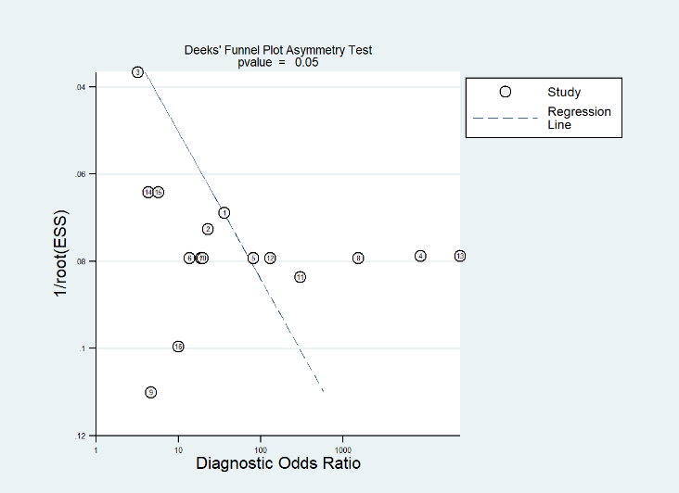
Fig. S1. Deeks ’Funnel Plot of diagnostic odds ratio, asymmetry test and p-value for all included studies

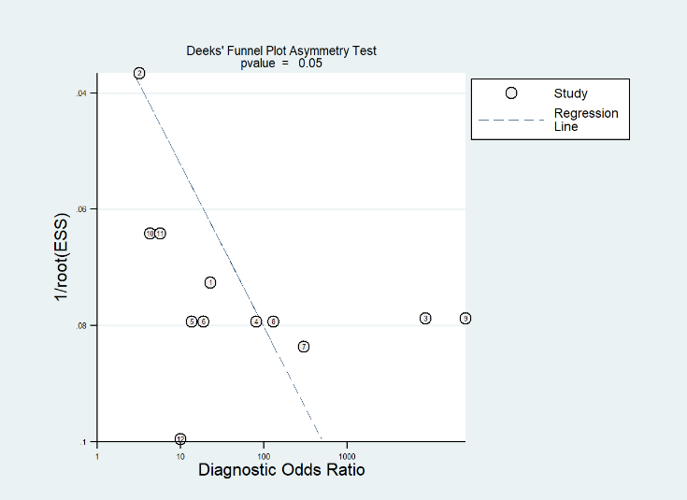
Fig. S2. Deeks ’Funnel Plot of diagnostic odds ratio, asymmetry test and p-value for upregulated miRNAs studies

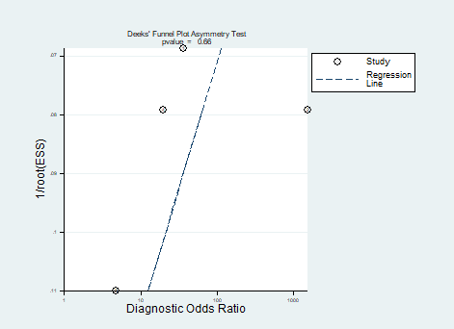
Fig. S3. Deeks ’Funnel Plot of diagnostic odds ratio, asymmetry test and p-value for downregulated miRNAs studies

Table S1. Subgroup analyses of upregulation or downregulation of included studies
Subgroup | LSCC | Healthy | Total | TP | FP | FN | TN | Sensitivity(95%CI) | Specificity(95%CI) | PLR | NLR
Dysregulation : up
Enzhu Zhang,2016 | 112 | 112 | 194 | 97 | 18 | 15 | 64 | 0.87 [0.79-0.92] | 0.78 [0.68-0.86] | 3.945 | 0.169
Jianling Wang,2016 | 280 | 280 | 840 | 164 | 171 | 116 | 389 | 0.59 [0.53-0.64] | 0.69 [0.65-0.73] | 1.915 | 0.599
Jingting Wang,2014 | 52 | 52 | 101 | 36 | 9 | 16 | 40 | 0.69 [0.55-0.81] | 0.82 [0.68-0.91] | 3.761 | 0.377
WL.Grzelczyk(1) 2019 | 66 | 66 | 166 | 66 | 1 | 0 | 99 | 1.00 [0.95-1.00] | 0.99 [0.82-0.95] | 100.000 | 0.000
WL.Grzelczyk(2) 2019 | 66 | 66 | 166 | 61 | 13 | 5 | 87 | 0.92 [0.83-0.97] | 0.87 [0.79-0.93] | 7.077 | 0.092
WL.Grzelczyk(3) 2019 | 66 | 66 | 166 | 38 | 9 | 28 | 91 | 0.58 [0.45-0.70] | 0.91 [0.84-0.96] | 6.444 | 0.462
WL.Grzelczyk(4) 2019 | 66 | 66 | 166 | 57 | 25 | 9 | 75 | 0.87 [0.76-0.94] | 0.75 [0.65-0.83] | 3.480 | 0.173
WL.Grzelczyk(7) 2019 | 66 | 66 | 166 | 65 | 0 | 1 | 100 | 0.98 [0.92-1.00] | 1.00 [0.96-1.00] | 1.000 | 0.020
WL.Grzelczyk(9) 2019 | 66 | 66 | 166 | 65 | 19 | 1 | 81 | 0.98 [0.92-1.00] | 0.81 [0.72-0.88] | 5.158 | 0.025
WL.Grzelczyk(10) 2019 | 66 | 66 | 166 | 59 | 6 | 7 | 94 | 0.89 [0.79-0.96] | 0.94 [0.87-0.98] | 14.833 | 0.117
WL.Grzelczyk(11) 2019 | 66 | 66 | 166 | 66 | 0 | 0 | 100 | 1.00 [0.95-1.00] | 1.000 [0.96-1.00] | 1.000 | 0.000
Yang Meng(1),2018 | 154 | 154 | 254 | 112 | 38 | 42 | 62 | 0.73 [0.65-0.80] | 0.62 [0.52-0.72] | 1.921 | 0.435
Yang Meng(2),2018 | 154 | 154 | 254 | 103 | 26 | 51 | 74 | 0.67 [0.59-0.74] | 0.74 [0.64-0.82] | 2.577 | 0.446
Dysregulation : down
Bin Zhou ,2016 | 107 | 104 | 211 | 92 | 15 | 15 | 89 | 0.86 [0.78-0.92] | 0.86 [0,77-0.92] | 5.972 | 0.164
WL.Grzelczyk(5) 2019 | 66 | 100 | 166 | 62 | 1 | 4 | 99 | 0.94 [0.85-0.98] | 0.99 [0.95-1.00] | 94.000 | 0.061
WL.Grzelczyk(6) 2019 | 66 | 100 | 166 | 50 | 12 | 16 | 18 | 0.76 [0.64-0.85] | 0.88 [0.80-0.94] | 6.333 | 0.273
WL.Grzelczyk(8) 2019 | 66 | 100 | 166 | 62 | 44 | 4 | 56 | 0.94 [0.85-0.98] | 0.56 [0.46-0.66] | 2.136 | 0.107

